Low Level Design Template

DMT/AD06/TMP

Project Code
Project Name

Prepared/Modified by | Role | Date of Preparation
Reviewed by | Role | Date of Review
Approved by | Role | Date of Approval
Circulation List |  | Version Number of the template:1.0
Version Number | <version No >

Table of Contents

1. Description Of The Unit 3
2. References 4
3. Dependencies / Assumptions 5
4. Class Diagrams 6
5. Sequence Diagrams 7
6. Design Components 8
6.1 List Of UI Components 8
6.2 List Of Design Classes 8
7. Re-Usable Routines/Components 9
8. Messages 10
9. Configuration Files 11
10. Crud Matrix Table 12
11. Data Mapping Matrix 13
12. Action Flow Matrix 14
13. Stored Procedures 15
14. Program Specification / Pseudo Code 16
REVISION HISTORY OF THE WORK PRODUCT 17

Description Of The Unit

JEEVAN INSURANCE IS A PRIVATE BIKE INSURANCE COMPANY. IT DEALS WITH THE CLIENT FOR BIKE INSURANCE OF PREMIUM PER YEAR. A CLIENT CAN CLAIM INSURANCE THREE TIMES PER YEAR.
INSURANCE CLAIM CONSISTS OF TWO CATEGORIES –
- MINOR-ACCIDENT (30-60%)
- MAJOR- ACCIDENT (60-100%)
OUR COMPANY DEALS WITH THE THIRD PARTY INSURANCE AND COMPREHENSIVE INSURANCE (OR STANDARD INSURANCE). EVALUATION OF VALID AND INVALID INSURANCE IS DONE.
CALCULATION OF PREMIUM IS DONE ON THE BASIS OF FEW FACTORS LIKE DAMAGE CAUSED TO THE VEHICLE, INSURED AND PASSENGER.
NCB (NO CLAIM BONUS) IS ALSO PROVIDED.

References
<Write the relevant References referred to prepare the LLD>

Dependencies / Assumptions

- INSURANCE COMPANY- JEEVAN (G-1) INSURANCE.
- ONLY FOR BIKE INSURANCE OF 3-4 MODELS.
- ONLY CLIENT AND ADMIN ACCESS.
- INSURANCE ONLY FOR 5 YEARS.
- INPUT FILE IS SORTED.
- CLAIM DATE IS GREATER THAN THE COMPANY OPENING DATE AND BIKE PURCHASE DATE.
- PREMIUM IS CALCULATED PER YEAR AND IS TO BE PAID BY THE CLIENT.
- A CLIENT CAN CLAIM INSURANCE 3 TIMES PER YEAR.
- BENEFIT IS PROVIDED UPTO RS. 25000 PER CLAIM.

Class Diagrams

Sequence Diagrams
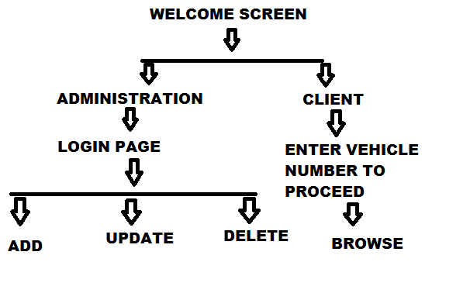

Design Components

List Of UI Components
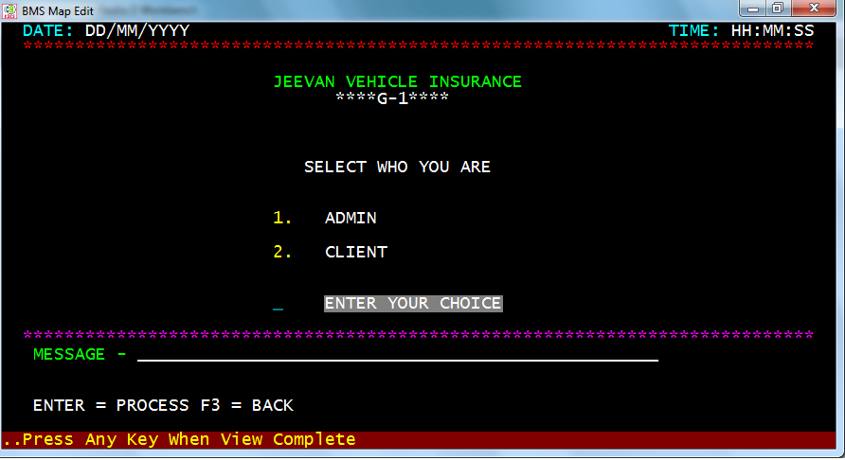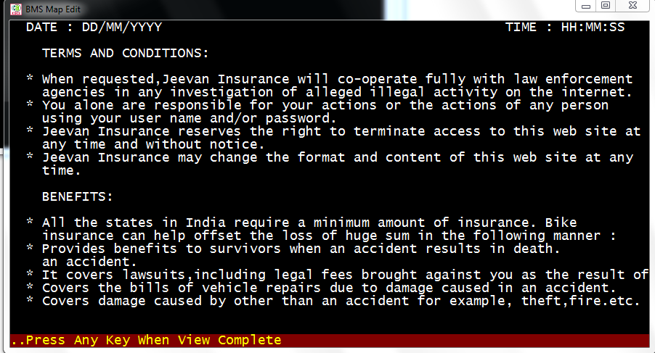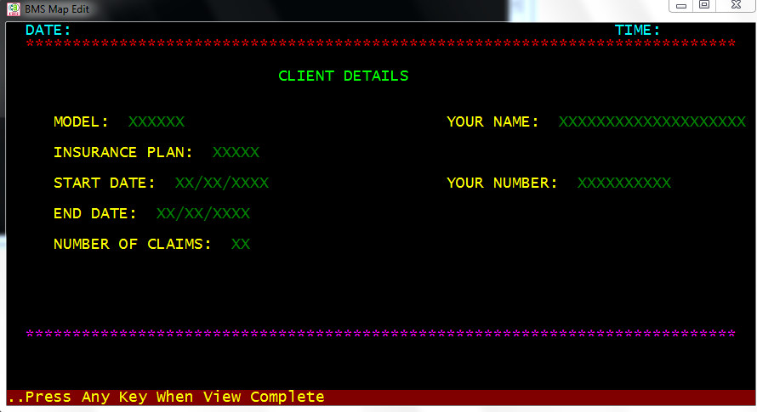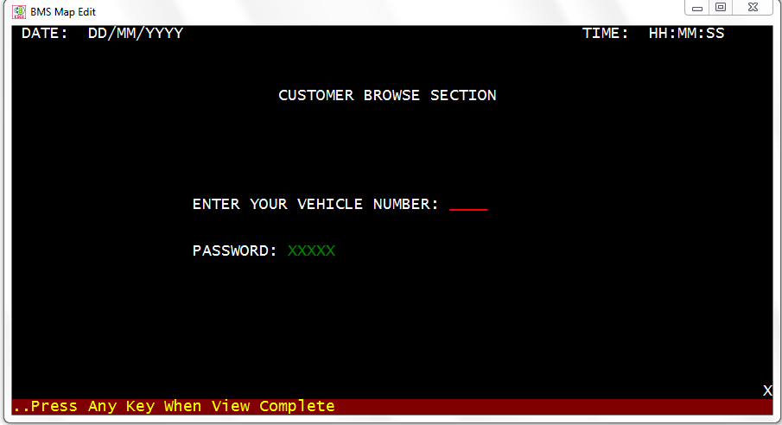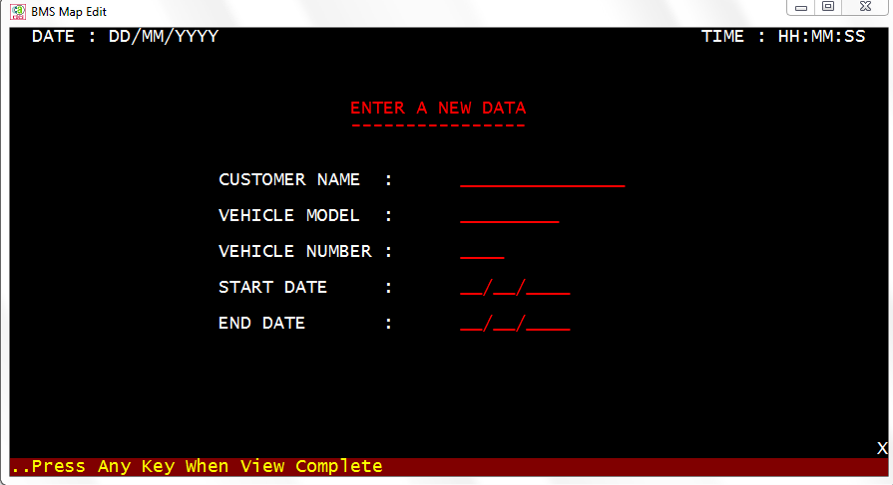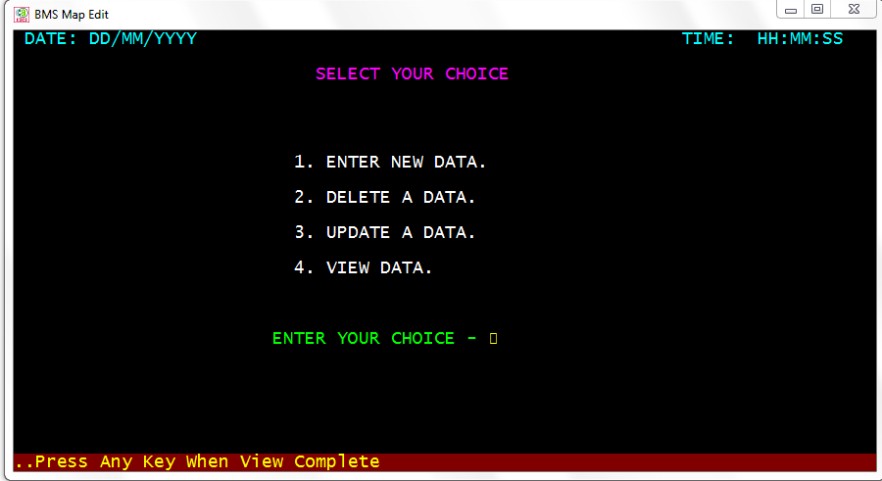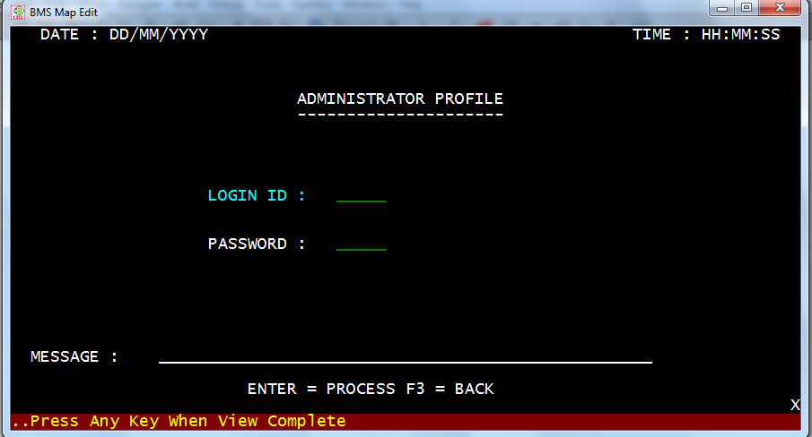

List Of Design Classes

Re-Usable Routines/Components
<provide references to the re-usable routines, copybooks and templates used by the unit>

Messages
<describe what are relevant messages which has to be displayed in this program unit>

#. | Type | Message Text
1. | <Warning/Information/Validation/Error>

Configuration Files
<< Provide complete list of configuration files that will be required during deployment of the application. This list will comprise of all the XML files, resource files packaged within application deployment>>

File Name | Path | Description

Crud Matrix Table

# | Table Name | Create | Read | Update | Delete

Data Mapping Matrix
<identify data-mapping matrix pertinent to screen or report data items. Provide details of the base table or column, screen item name, length, calculations and validations.>

Action Flow Matrix
<identify the action flow matrix detailing all actions and triggers associated with the unit. Provide details of processing and the enabled conditions>

Stored Procedures
<describe what are Stored Procedures Pertaining to this program unit >

# | Stored Procedure Name  (with Description) | Input/Out Parameters | Type | Size
1.

Program Specification / Pseudo Code
<specify processing details of the unit >

REVISION HISTORY OF THE WORK PRODUCT
<to be maintained by projects>

# | Date | Version # | Section Changed | Details of changes made | Approved By
1
2

